Ch. 4 Human Body System Images for PPTs

Chapter 4

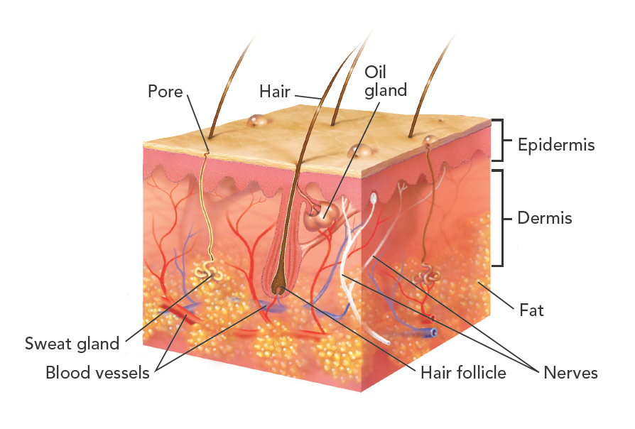

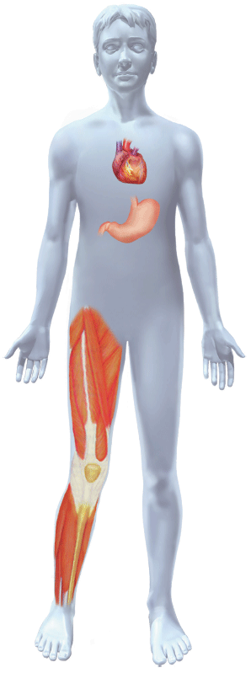

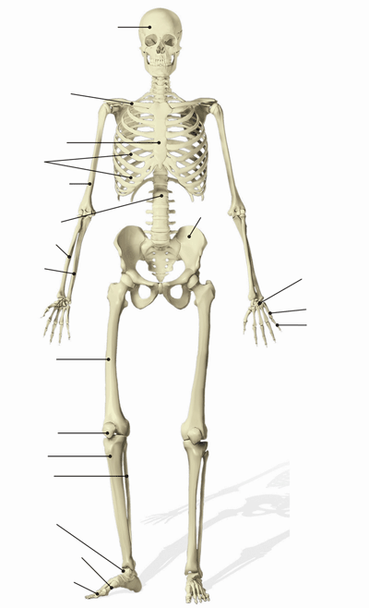

Skull

Clavicle

Sternum

Ribs

Humerus

Vertebral

column

Ulna

Radius

Femur

Patella

Tibia

Fibula

Tarsals

Metatarsals

Phalanges

Pelvis

Carpals

Metacarpals

Phalanges

