Seminole County Science Safety Contract

The following list of safety procedures pertains to my safety in the science classroom:
- Horseplay in the science classroom is dangerous. I will practice appropriate conduct in the classroom, such as walking, using a quiet voice, keeping my hands off others, etc. I will keep my mind and eyes on what I am doing.
- I will follow written and verbal instructions concerning procedures and/or precautions. They are created for my protection.
- I will keep my personal belongings in the location that is designated by my teacher.
- Experiments done in class are for instruction. They are planned to teach an idea or concept. I will perform only authorized experiments.
- I will handle only those chemicals or equipment for which I have received instruction. I will be extremely careful with handling and storage of chemicals, equipment, and sharp objects.
- Chemicals are labeled to identify them. I will always read the label to make sure I am using the correct substance. Mixing and handling chemicals or other substances can be dangerous. I will not do so unless instructed in a planned and approved experiment.
- When working with fire, I will not reach across a flame or bring any unauthorized substances near flames. I will not burn objects. I will keep long hair away from fire. I will never leave a burner unattended.
- I will dress appropriately. I will tie long hair back, avoid wearing open shoes, dangling jewelry, and floppy sleeves.
- Safety equipment is provided in the science classroom in case of an emergency. I know how and when to use this equipment. I know where the eyewash station, fire blanket, and extinguishers are located.
- It is required by law to wear safety goggles for many laboratory situations. To prevent injury, I will wear my goggles as instructed by the teacher.
- Broken glass is dangerous. If an accident occurs, I will report it immediately to the teacher.
- I will be careful not to write in books, on tables, on lab counters, or on desks. I realize that this is a form of vandalism and I will be held responsible for my behavior.
- I will clean up after myself and my lab team. A messy area contributes to accidents.
- I will not eat, drink, or chew gum in the science classroom, unless given permission from my teacher.
- Cheating and or plagiarism will result in failure of the assignment. All work turned in by my classmates and me must be completely our own.
- I will work to stop any bullying going on around me. Bullying is bad news; I will work cooperatively within the classroom.

Please sign and return this form to the teacher.

Student Name: __________________________________________________________ Period: ___________________

I have read the science safety rules. I understand these rules have been created for my protection. I agree to follow them and do my part to make my science classroom a safe place to learn.

For the Parent/Guardian:

Laboratory activities are integral to the science curriculum. Student safety is our highest priority, and is enhanced by awareness and caution. Please help us to assure a safe and positive learning experience for your child by completing the items below:

- Does the student have any health problems, physical limitations, or allergies? YES NO
If yes, please specify: ____________________________________________________________________________
- Does the student wear contact lenses? YES NO

I have reviewed the above student guidelines for laboratory safety with my child. I will direct any questions I may have concerning laboratory activities to the science teacher.

Parent/Guardian Signature: _______________________________________________ Date:_____________________
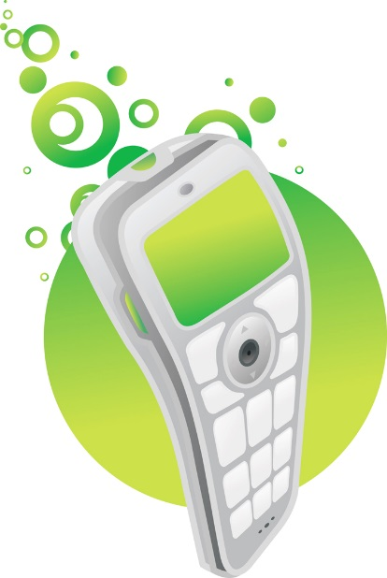

Permission Slip for Classroom Related Technology

To enhance student learning and prepare your child for our hi-tech world, technology will be integrated into our classroom including the use of cell phones and MP3 players/iPods. These devices will be used only with teacher supervision and strictly for academic purposes. Students will not be able to use these devices for any general purpose or for socializing while at school. I am sending this permission form for you to authorize the academic use of a cell phone, MP3 player/iPod, or Kindle. Please note that students are required to have a separate permission slip for each class that uses technology. I look forward to implementing these instruments in our classroom for exciting instruction. Please encourage your student to be very cautious with the technology they bring to school. Neither the school nor the Seminole County School Board is responsible for the replacement or repair of any technology students bring to school.

Teacher: Subject: SCIENCE

_____ I give permission for my child to use a cell phone for academic purposes.
_____ I give permission for my child to use an MP3 player/iPod for academic purposes.
_____ I give permission for my child to use a Kindle, Nook or other electronic reader for
academic purposes.

Student Name_______________________________________ Class Period______

_________________________________ _________________________
Parent Signature Date

